Assessment Schedule – 2013
Physics: Demonstrate understanding of mechanical systems (91524)
Evidence Statement
Achievement | Achievement with Merit | Achievement with Excellence
Demonstrate understanding requires writing statements that typically show an awareness of how simple facets of phenomena, concepts or principles relate to a described situation. For mathematical solutions, relevant concepts will be transparent, methods will be straightforward. | Demonstrate in-depth understanding requires writing statements that will typically give reasons why phenomena, concepts or principles relate to given situations. For mathematical solutions the information may not be directly usable or immediately obvious. | Demonstrate comprehensive understanding requires writing statements that will typically give reasons why phenomena, concepts or principles relate to given situations. Statements will demonstrate understanding of connections between concepts.

Evidence Statement
NØ = No response; no relevant evidence.

GENERAL GUIDELINES
- An Excellence is worth at least one Merit (look at Merit statements to see if it is worth more than one Merit)
- A Merit is worth at least one Achieved (look at Achieved statements to see if it is worth more than one Achieved)
- Symbols can be used in place of words in explanations for all levels
- Accept in place of “gravitational force” – “weight” or “gravity”
- Transcription errors (when you see the number they should have written, but there is a small change) – ACCEPT
- Full substitution and wrong answer - ACCEPT FOR ACHIEVED, DROP ONE MARK FOR MERIT AND EXCELLENCE (Use this rule if they forget the x10?)

Q1 | Evidence |  | Achievement |  | Merit |  | Excellence
(a) | SHOW THAT QUESTION  ω = 2πf = 2π × 2.70 = 16.965 = 17 rad s⁻¹  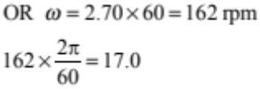 |  | - 2π × 2.70  OR working via 162 rpm
(b) | SHOW THAT QUESTION  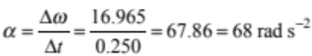  Or using  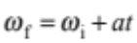 |  | - Correct working – equation and substitution
(c) | 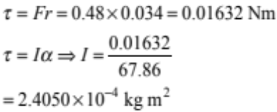  OR uses  I = 2 / 3 mr²  Note: Using L = mvr gets N |  | - Correct τ.  - Uses equation correctly with any value of .  - Calculates an I using an mr² relationship, eg I = mr (3.5836 × 10^{–4}) |  | - Correct answer. Unit not needed. |  | - Both equations correct (or 2/3mr² shown), with answer and unit (acceptable units: kg m², N m s²,  N m s² rad^{–1}, kg m² rad^{–1})
(d)(i) | A ball thrown with the same linear speed will reach the same height, 1.4m. The balls both have the same linear kinetic energy, which turns into the same amount of gravitational potential energy. As a result the balls both reach the same height of 1.4m. The rotation of the ball does not affect the height because the rotating ball stays rotating at the same angular velocity, so the rotational kinetic energy does not change, so the gravitational potential energy is not affected |  | - Same height/ 1.4 m  - Non rotating ball goes to a lower height because there is less E_{Ktotal}, so there is less E_{Pgrav}. |  | - Same height  AND (linear kinetic energy is turned into gravitational potential energy  OR  Rotational kinetic energy does not change).  - The two balls have the same force/s/acceleration acting, so they reach the same height.  OR  The rotation does not affect the force/s/acceleration so they reach the same height. |  | - Linear kinetic energy is turned into gravitational potential energy, they have the same linear kinetic energy, so they reach the same height.  AND  angular velocity/rotational kinetic energy doesn’t change/affect the height  - The two balls have the same net force/ gravitational force acting, and the same initial speed, so they reach same height  AND  angular velocity/rotational kinetic energy doesn’t change/affect the height
(d)(i) | Because a solid ball has a significant proportion of its mass closer to the centre of rotation it would have a smaller rotational inertia than the hollow ball.  If both balls are given the same angular speed the solid ball needs less work to get it rotating than the hollow ball.  If less work is done to get the ball rotating, more of the total work is done to give the ball linear velocity so it will have a greater release speed and so will rise higher because it has more kinetic energy that is changed to gravitational potential energy. |  | - Solid ball has a smaller rotational inertia.  - Solid ball goes to a greater height.  Note: Accept “inertia”. |  | - Smaller rotational inertia because the solid ball has mass closer to the centre.  - Less work done / energy to get the same spin of the solid ball OR more work / energy going into linear velocity / linear energy of the solid ball. (or less replaced with more IF they think I gets bigger)  - Less rotational kinetic energy because I is smaller (OR less replaced with more IF they think I gets bigger).  - Links linear kinetic energy to gravitational potential energy to height (even if height is incorrect).  Note: Accept “inertia”. |  | - Links – solid ball has smaller I because mass is closer to centre of rotation therefore  - E_{Krot} is smaller – Work / E_{total} is the same for both therefore  - E_{Klin} is greater – E_{klin} turns into E_{Pgrav} - therefore the ball goes higher.  Note: Accept “inertia”.
Q1 | Not Achieved |  | Achievement |  | Achievement with Merit |  | Achievement with Excellence
Q1 | N1 | N2 | A3 | A4 | M5 | M6 | E7 | E8
Q1 | ONE A point | TWO A points | THREE A points | FOUR A points | TWO M points | THREE M points from two different question parts | ONE E point plus ONE M point from a different q part to the E point | TWO E points

Q2 | Evidence | Achievement | Merit | Excellence
(a) | 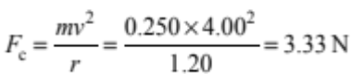 | - Correct answer OR correct working (equation and substitution)
(b) | The total amount of kinetic and gravitational potential energy of the ball is conserved. As the ball goes down the gravitational potential energy is changed into kinetic energy. At the bottom of the circle the ball has the least gravitational energy so it has the greatest amount of kinetic energy, therefore it must be moving fastest here. | - Maximum/high speed linked to maximum/high kinetic energy.  - Gravitational force/weight has sped the ball up as it goes down  - Centripetal force/Net force is greater at the bottom, so velocity is higher  - Gravitational potential energy at the top is converted to kinetic energy.  OR  Statement of conservation of energy, and mentions GPE and KE. | - Gravitational potential energy at the top is CHANGED into kinetic energy at the bottom so it goes faster.  OR  Energy is conserved. At the bottom the gravitational potential energy is the smallest, so the kinetic energy is the largest, therefore it goes faster at this point.  - There is a tangential force which accelerates the ball as it goes down
(c)(i)  (c)(ii) | 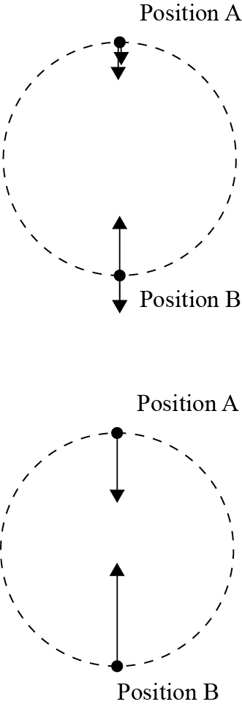 | - THREE vectors in correct directions.  - (Tension in correct directions, larger at the bottom.  OR  Centripetal force in correct directions, larger at the bottom). | - All vectors in correct directions and (tension OR centripetal force) shown as larger at bottom. | - All vectors in correct directions AND  - tension larger at bottom than top  - centripetal force larger at bottom than top  - centripetal force at top is larger than tension or gravity  - centripetal force at bottom is smaller than tension force at the bottom.
(d) | SHOW THAT QUESTION  At the top of the circle, where the speed is least, the centripetal force is the sum of the gravity force and the tension force. The minimum centripetal force is therefore when the tension force is zero and so the centripetal force is provided by the gravity force.  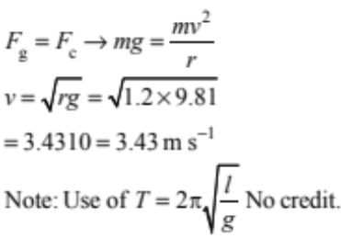  Note: Be cautious of working – F_{c}=9.81 gives 6.86, which then students divide by 2 to get 3.43. This is not worth M. Check to see if they have achieved points. | - Equates Fg to Fc (words, symbols or equations, Fc=9.81×0.25 is sufficient)  - Tension force is zero  - Rearranges 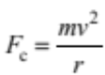 to get v.  - Uses equation 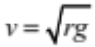 to get correct speed.  Note: Accept g = 9.81 or 9.8 or 10 | - Only force acting is the gravitational force OR gravitational force IS the centripetal force OR tension force=0 therefore centripetal force = gravitational force  - Some correct working shown (equation OR substitution). Use of 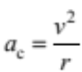 okay. | - Correct working (equation AND substitution).  AND  - gravitational force IS the centripetal force.  OR tension force = 0, therefore centripetal force = gravitational force.  Note: stating F_{c} = F_{g} is not the same as F_{c} IS F_{g}.

(e) | SHOW THAT QUESTION  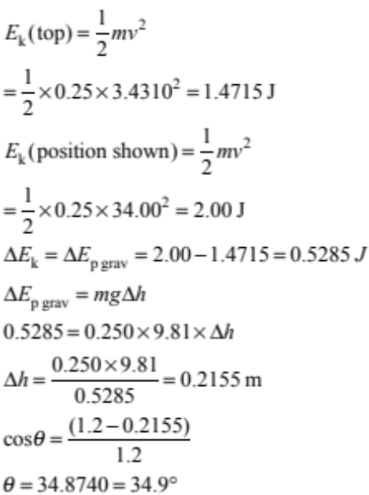 |  | - Either E_{K} calculated (at position shown (2J) or at top(1.41715J))  - Correct E_{Pgrav} at top (from middle of circle = 2.943J or from bottom of circle 5.886 J)  OR  Difference in E_{Pgrav} = 0.5285J |  | - A correct height – (0.2155 from top, or 0.9835 from middle or 2.1835 from bottom).  Note: Doesn’t have to explain where this is measured from  A height using E_{Pgrav} = 2 J (0.815 m) or E_{Pgrav} = 1.47 J (0.599 m) is not acceptable. |  | - Correct working – Some evidence of E_{pgrav} and E_{K} equations used and trig used.
Q2 | Not Achieved |  | Achievement |  | Achievement with Merit |  | Achievement with Excellence
Q2 | N1 | N2 | A3 | A4 | M5 | M6 | E7 | E8
Q2 | ONE A point | TWO A points | THREE A points from two different question parts | FOUR A points from three different question parts | TWO M points from different parts | THREE M points | ONE E point plus one Merit from a different question part | TWO E points

Q3 | Evidence |  | Achievement |  | Merit |  | Excellence
(a) | SHOW THAT QUESTION  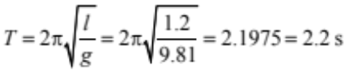 |  | - Correct equation OR substitution.
(b) | Angle of the swing must be small, so that the motion can be approximated as a straight line and the force is proportional to the displacement. |  | - Angle / amplitude must be kept small.  - The motion can be approximated to a straight line OR force / acceleration is proportional to displacement OR force / acceleration is towards the equilibrium position. |  | - Angle / amplitude / initial displacement is small  AND  (the motion of the ball can be approximated to a straight line OR force / acceleration is proportional to displacement OR force / acceleration is towards the equilibrium position).
(c) | Energy  Time |  | - Downwards sloping line.  - Oscillation with constant period that decreases with time. |  | - Line has negative slope with a decreasing size of slope.
(d) | The ball will start oscillating if the frequency of the shaking matches the natural frequency of the pendulum. If the frequencies are the same, resonance will occur, which means the energy used for the shaking will be transferred into the ball, giving it kinetic energy to make the ball swing. |  | - Shake at (resonant frequency OR natural frequency OR same time each cycle).  - E_{Pgrav} ≤ ≥ E_{K} as ball oscillates.  - Standing wave set up (or words describing this). |  | - Shaking at (resonant frequency OR natural frequency OR same time each cycle).  AND  will cause (large amplitude OR large energy transfer OR energy transferred from shake to ball ).  - Wave reflects / interferes and standing wave is set up.  - Shake at (resonant freq OR natural freq OR same time each cycle) AND (E_{Pgrav} ≥ E_{K} as ball oscillates OR statement of conservation of energy).  - Force of hand pulls ball (increasing speed / acc / restoring force / amplitude OR causing acceleration / restoring force). |  | - Shaking at (resonant frequency OR natural frequency OR same time each cycle).  AND  Causes (energy to be transferred from shake to E_{Pgrav} or E_{K} of ball OR wave reflects and interferes producing standing wave).
(e) | The forces acting on the ball are the tension force and the gravitational force. The gravitational force is constant, and always acts downwards. The tension force changes direction as the ball swings because it always points in the direction of the cord.  Tension  Gravitational force  At each end of the swing, the tension plus the gravitational force add to make the net force which is the restoring force which is at a tangent to the path. The tension force balances the component of the gravitational force opposite to the direction of the string. The restoring force is the component of the gravitational force that is perpendicular to the string. As the displacement increases, the angle of the string increases, so the size of the restoring force increases.  F_{T}  F_{g}  F_{R}  Note: If students use the word “support” in place of tension, drop mark down by one. |  | - Gravitational force and tension identified as forces acting on the ball. (Symbols sufficient)  - Gravitational force does not change  Note: Accept air resistance included  - Acce |  | - Gravitational force and tension named and labelled diagram of tension at correct non-zero angle and gravitational force acting downwards. No incorrect forces (e.g. F_{c}).  - Tension increases displacement decreases because the centripetal force is greater because it is moving faster (curved)  OR  Tension increases as displacement decreases as tension force cancels a component of gravity (curved)  OR  Tension decreases as displacement decreases as horizontal component of tension gets smaller (straight line)  OR  Tension decreases as displacement decreases as vertical component cancels gravitational force (straight line)  OR  Tension changes angle as it always acts towards the cord  OR  (Restoring force is component of (tension or gravitational force) AND restoring force increases with greater angle)  Note: Accept air resistance included. |  | - Labelled diagram showing restoring force created (with triangle OR components OR statement showing restoring force is the addition of gravitational force and tension). No incorrect forces (e.g. F_{c}).  AND  Tension increases displacement decreases because the centripetal force is greater because it is moving faster  OR  Tension increases as displacement decreases as tension force cancels a component of gravity  OR  Tension decreases as displacement decreases as horizontal component of tension gets smaller  OR  Tension decreases as displacement decreases as vertical component cancels gravitational force  OR  Tension changes angle as it always acts towards the cord  OR  (Restoring force is component of (tension or gravitational force) AND restoring force increases with greater angle)  Note: Accept air resistance included.
Q3 | Not Achieved |  | Achievement |  | Achievement with Merit |  | Achievement with Excellence
Q3 | N1 | N2 | A3 | A4 | M5 | M6 | E7 | E8
Q3 | ONE A point | TWO A points | THREE A points from two different parts | FOUR A points from three different parts | TWO M points from two different parts | THREE M points from two different question parts | ONE E point plus one M point from another question part | TWO E points

Judgement Statement
 | Not Achieved | Achievement | Achievement with Merit | Achievement with Excellence
Score range | 0 – 7 | 8 – 13 | 14 – 18 | 19 – 24

